Data CO1

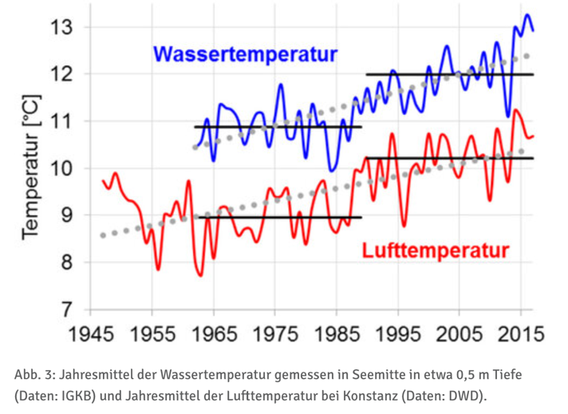
Temperature:

Datapoints from 1945-2015, the text states that the average water temperature from 1990-2017 was on average 1.2° higher than in the 3 decades before
Water circulation is decreasing because of milder winters and higher water temperatures.

Stuff to think about:
- How do we represent the seasonal differences or do we do this at all and just look at the fitted points and the rising of temperature in general?
- The temperature was measured in a depth of 0.5 meters, it will be cooler deeper and O2 Levels where measured at almost the deepest point of the lake

https://www.igkb.org/medien/faktenblaetter/zirkulation-im-bodensee-oktober-2018
https://umweltportal.baden-wuerttemberg.de/umweltdaten-bericht-2024/bodensee-gewaesserqualitaet

O2 Levels:
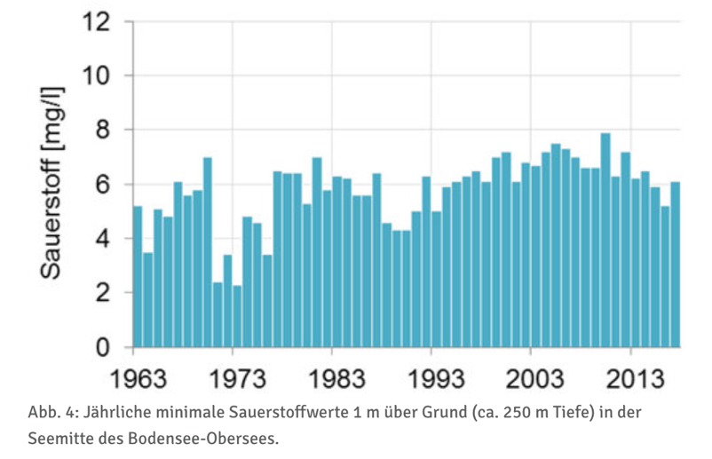

Datapoints from 1963-2013
The text states that for a large and deep alpine lake such as Lake Constance, maintaining a good oxygen supply of more than 6 mg/L in the deep water is essential. It provides enough oxygen for whitefish eggs and deep-water organisms and prevents nutrients and pollutants from being released from the sediment back into the lake water.

https://www.igkb.org/medien/faktenblaetter/zirkulation-im-bodensee-oktober-2018
https://umweltportal.baden-wuerttemberg.de/umweltdaten-bericht-2024/bodensee-gewaesserqualitaet

Nutrients:
Phosphor
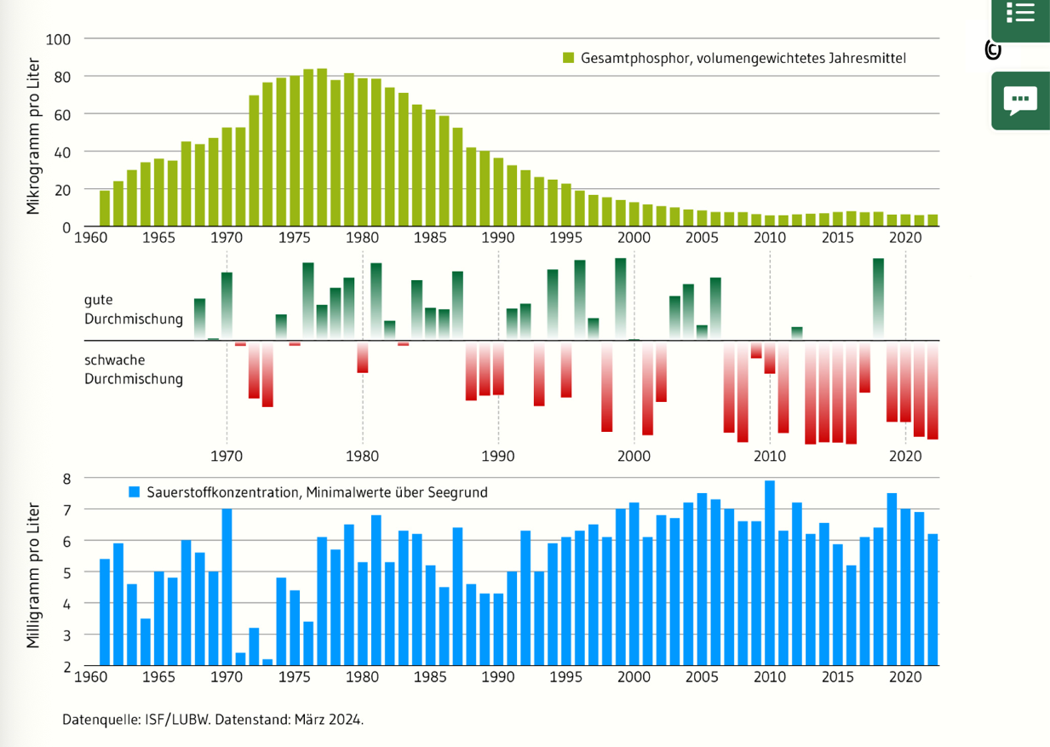

The text states that phosphor and O2 levels are connected, therefore also the overview.
Sewage treatment plant helped to reduce the phosphor levels

https://www.igkb.org/medien/faktenblaetter/phosphor-im-bodensee-oktober-2018

Nitrogen and chloride:

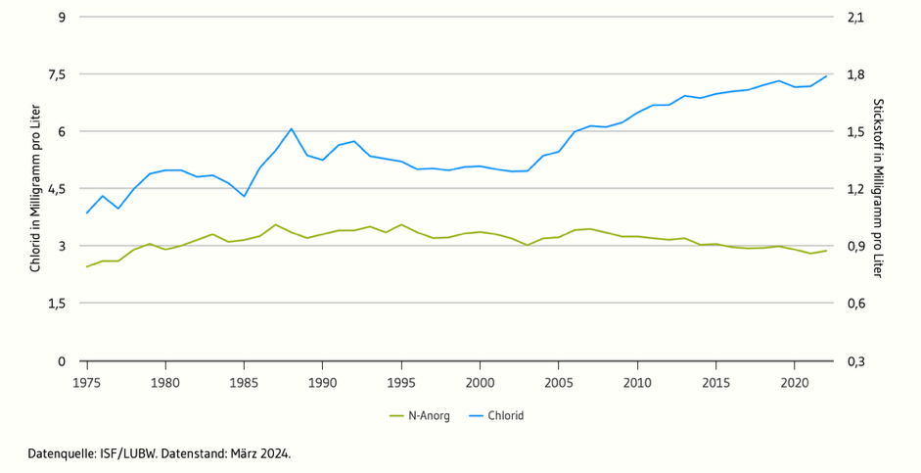

A significant proportion of the increase chloride levels is attributed to the use of road salt in winter
There is also information on Chlorophyll a and Phytoplankton on this website

https://umweltportal.baden-wuerttemberg.de/umweltdaten-bericht-2024/bodensee-gewaesserqualitaet

Fish:
Suggested species: whitefish (Felchen), important and characteristic for lake Constanze, a lot of fishing was done, sensitivity to temperature, O2 levels and phosphor concentration

Fishing of whitefish:
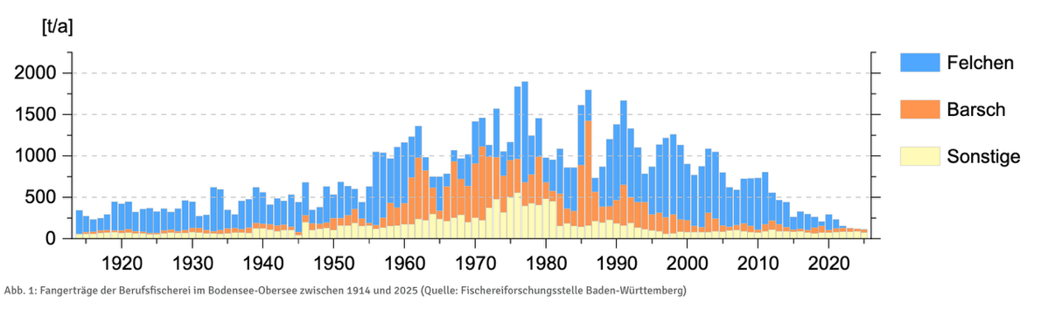
Important to note:
Since 2024 it is prohibited to fish whitefish in lake Constanze

https://www.igkb.org/daten-karten/fischereirechte-und-fischschongebiete
https://www.srf.ch/news/schweiz/mehr-felchen-im-bodensee-kompromiss-felchen-fangverbot-im-bodensee-wird-leicht-gelockert

Population of whitefish 2025, broken down by age
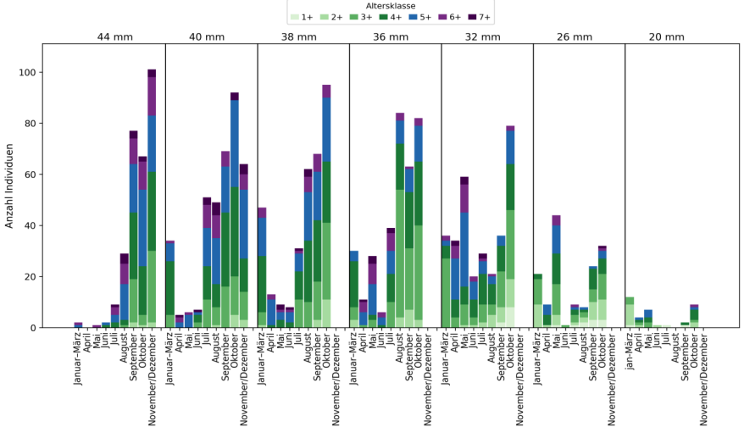
https://ibkf.org/wp-content/uploads/2026/06/IBKF-2026-Blaufelchenbericht-Fangjahr-2025.pdf

Egg production over the years
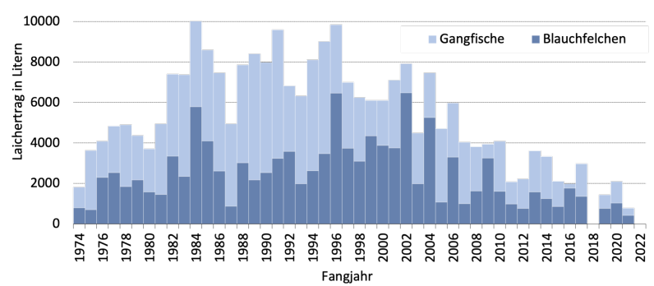

https://www.bafu.admin.ch/dam/en/sd-web/hB7f48W1BnO2/die-aussergewoehnliche-vielfalt-der-felchen-der-schweiz.pdf

Phosphorus content and survival rate of whitefish eggs

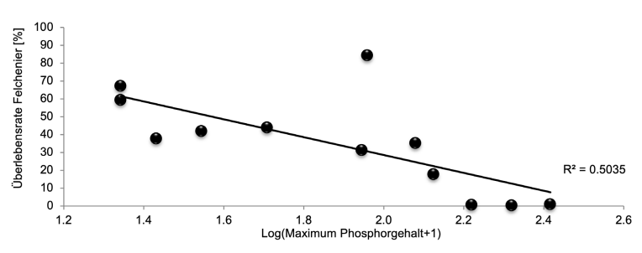
https://www.bafu.admin.ch/dam/en/sd-web/hB7f48W1BnO2/die-aussergewoehnliche-vielfalt-der-felchen-der-schweiz.pdf

Connections:
Phosphor -> Algae -> O2 Levels -> Phosphor
High phosphorus levels lead to increased algal growth. When the algae die, they sink to the bottom of the lake, where bacteria decompose them and consume oxygen in the process. As a result, high phosphorus levels lead to low oxygen levels in the deep water of the lake.
https://www.igkb.org/medien/faktenblaetter/phosphor-im-bodensee-oktober-2018

Phosphorus is stored in the sediment, bound to insoluble iron(III) compounds. When oxygen levels at the lake bottom drop close to zero, bacteria use iron(III) instead of oxygen for respiration and convert it into soluble iron(II). As a result, the bound phosphorus is released into the water. This only happens when oxygen levels are close to zero; above that, the effect is negligible. This means that near-zero oxygen levels in the deep water lead to a release of phosphorus from the sediment.
https://umwelt.tg.ch/public/upload/assets/12827/Faktenblatt-Phosphor-im-Bodensee.pdf?fp=2

O2 Levels -> survival fish roe
Whitefish eggs sink to the bottom of the lake and lie there over the winter. If there is too little oxygen, they die. This means that lower oxygen levels in the deep water lead to fewer fish hatching.
https://www.igkb.org/fileadmin/user_upload/Presse/IGKB_Pressemitteilung_KT2014_def.pdf
The adult fish live in the open water, which is well supplied with oxygen throughout the year.

Water temperature -> O2 Levels in the deep water
The higher the water temperature in winter, the worse the lake mixes, and therefore the lower the oxygen levels in the deep water.
https://www.igkb.org/fileadmin/user_upload/Downloads/Pressemitteilungen/IGKB_Pressemitteilung_Zirkulation_April2026.pdf

Water temperature -> survival of the fish larvae
The higher the water temperature, the higher the mortality rate of whitefish larvae and fish roe.
https://www.bluewin.ch/en/news/lake-constance-could-become-too-warm-for-whitefish-li.2265403

Algae -> zooplankton
Zooplankton feeds on algae. The more algae there are in the lake, the more food is available for zooplankton. This means that higher algae levels lead to more zooplankton.
https://www.igkb.org/fileadmin/user_upload/Downloads/Forschungsprojekte/IGKB_Monitoring/Datenblatt_Plankton_Schlussversion.pdf

Zooplankton -> whitefish births
Whitefish feed mainly on zooplankton. When more food is available, the fish are in better condition and produce more eggs. This means that more zooplankton leads to more whitefish hatching.
https://gepris.dfg.de/project/5429777

Whitefish adults -> zooplankton
Whitefish feed on zooplankton. The more adult whitefish there are in the lake, the more zooplankton is eaten. This means that a larger whitefish population leads to less zooplankton. Together with the previous connection, this forms a balancing feedback loop.
https://www.igkb.org/fileadmin/user_upload/Downloads/Forschungsprojekte/IGKB_Monitoring/Datenblatt_Plankton_Schlussversion.pdf

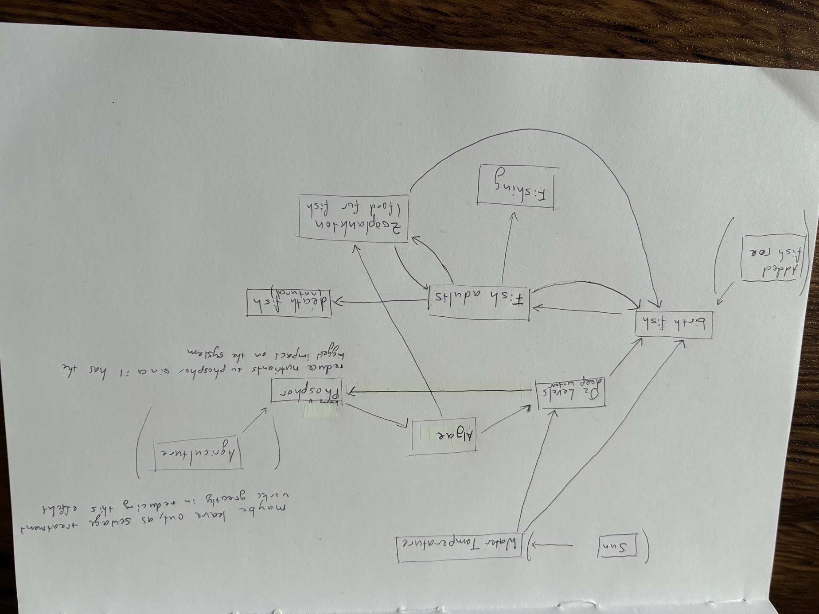

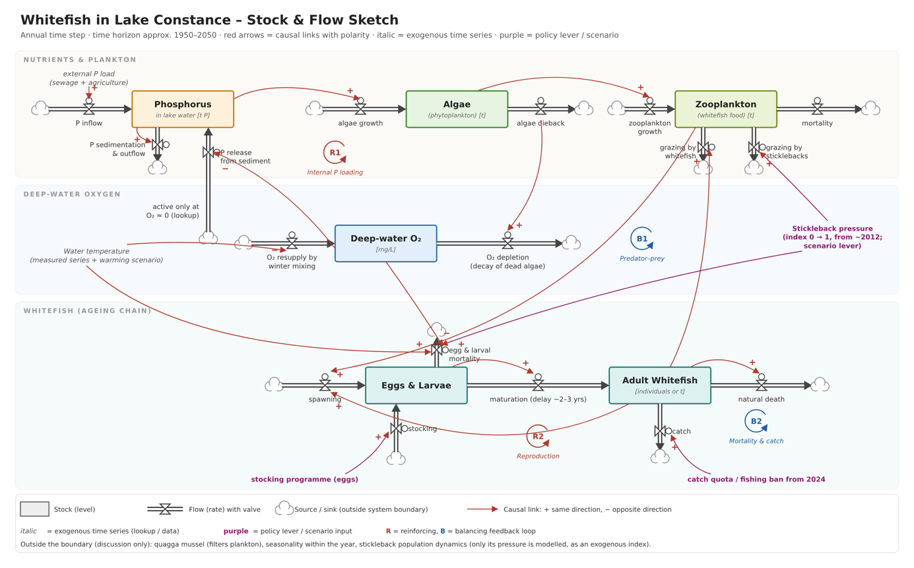

In this model we have 6 ODEs -> one for each stock

Input:
Water temperature
External P-load
Fishing rate
Stickleback index
Stocking (added fish eggs)

